 | CHBE 376: Computer Flowsheeting & Unit Operation Design

CHBE 376

Instructor: Jonathan Verrett

Term Project – [Title here – eg Cumene]

Submitted by:

Name: _______________________

Student ID: _______________________

Signature: _______________________

Contents
1. Process Description (a short introduction, suggest no more than 1 page) 3
2. Block Flow Diagram (to show your overall process) 4
3. Components 5
4. Property method 5
5. Reactor Setup 6
6. Analysis [eg. design spec, sensitivity analysis, calculator block, recycle stream, optimization]) 8
7. References 9

Update the table above by right clicking and selecting “Update Field”

Process Description (a short introduction, suggest no more than 1 page)
Our simulation will focus on the cumene process for the production of phenol and acetone. The process is widely used and was estimated to have generated approximately 7 million tonnes of phenol in 2003 alone [1]. The Cumene Process is comprised of three reactions carried out at varying conditions [2]:
C6H6 + C3H6 → C9H12 (1)
C9H12 + O2 → C9H12O2 (2)
C9H12O2 → C6H6O + C3H6O (3)
Reaction 1 is a synthesis reaction carried out at 30 atm pressure and 250°C combining vapour-phase benzene and propylene to produce cumene, and is commonly catalyzed with phosphoric acid [3]. Reaction 1 is conducted in the gas phase in order to achieve higher conversion than in the liquid phase [4]. In reaction 2 the oxygen from air is used to oxidize cumene and form cumene hydroperoxide; the cumene hydroperoxide autocatalyzes the reaction, and the reacting conditions are 5 atm and 95°C in order to ensure the reaction occurs in the liquid phase to keep the peroxides stable [3]. The third and final reaction is a decomposition reaction cleaving cumene hydroperoxide into phenol and acetone, which takes place also in the liquid-phase at 5 atm and 70°C, and is typically catalyzed with a low concentration sulfuric acid solution [5]. Catalysis will be ignored in this process simulation for each of the reactions.

Block Flow Diagram (to show your overall process)
This one was made using Visio, but feel free to use whichever program to create it, or even can be done by hand and scanned.
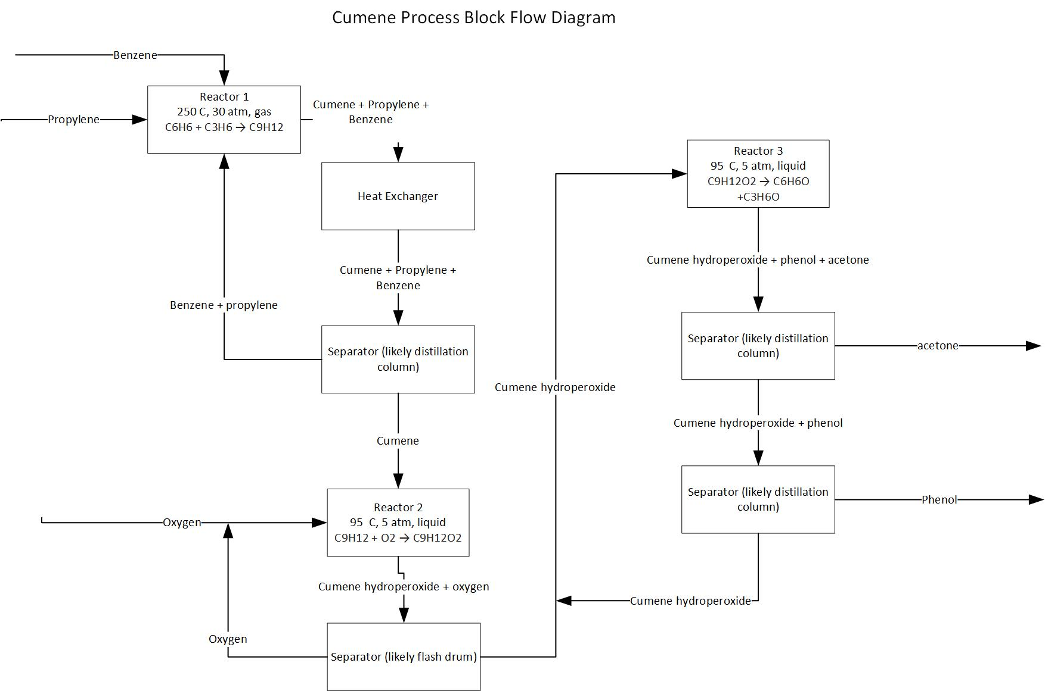
Figure 1: Block Flow Diagram for Cumene process

Components
The Cumene Process is comprised of three reactions carried out at varying conditions [2]:
C6H6 + C3H6 → C9H12 (1)
C9H12 + O2 → C9H12O2 (2)
C9H12O2 → C6H6O + C3H6O (3)
The major components relevant to the simulation are listed in table 1 below.
Name | Formula
Oxygen | O₂
Propylene | C3H6
Benzene | C₆H6
Cumene | C9H12
Cumene hydroperoxide | C9H12O2
Phenol | C6H6O
Acetone | C3H6O

Property method
Conditions in the process vary from 1 to 30 atm and 20 to 250°C. There are some non-hydrocarbon components namely oxygen, cumene hydroperoxide, phenol and acetone. Given this, this would be classified as a chemical system at high pressures. A suitable overall property method would be an equation of state method such as SR-POLAR, PRWS, RKSWS etc.

Reactor Setup
This reactor setup will focus on the cumene (C) production step, which was reaction (1) shown previously and is shown again for reference below. This is typically produced using a solid phosphoric acid catalyst (supported on alumina) or an aluminum chloride catalyst [6]. A common side reaction noted for this system is the formation of diisopropylbenzenes (DIPB), shown in reaction (4). These can also form further products including tri- or tetraisopropylbenzenes, however these further side reactions will simply be considered to be taken into account with the formation of DIPBs.
C6H6 + C3H6 → C9H12 (1)
C9H12 + C3H6 → C12H18 (4)
In many processes a mixture of propylene (P) and propane is mixed with fresh and recycled benzene (B). The propane is a common contaminant in propylene, but is generally not reactive. For this simulation we will assume a 95% propylene purity with the remainder being propane, this purity has been used in economic studies of the cumene process [6]. This mixture is typically preheated to temperatures ranging from 180 °C to 200 °C and fed into a fixed bed reactor at 550 psig. The reaction is exothermic and typically reactor temperatures will range from 350 °C to 410 °C [7]. Benzene is typically in large excess in these reactions in order to help moderate the exothermic reaction. Early technologies fed in benzene to propylene at ratio of 8:1, but processes have improved to now feed 5:1 with interbed injection. The greater the benzene feed, the more costly the separation of benzene for recycle, so there is a tradeoff between controlling the reaction and getting good conversion and the cost of separation. For this simulation we will aim to produce 1% of the total phenol used in the world, so 70,000 tonnes of phenol per year, this translates to 750 tonne-moles/yr. To start in our simulation, we will assuming an overall process efficiency of 80% and that the plant runs for 350 days per year. This means we need to feed 2650 kmol/day or 110 kmol/h of propylene into the process. This will be used as a starting basis. We will use a feed ratio of 5:1 benzene to propylene.
For this system, a plug flow reactor (RPLUG) will be used to simulate this reaction step. Kinetic data provided as an example by Turton et al. describes rates for the two relevant reactions in this process [7]. As is common with Aspen, the catalyst is not accounted for in the components and is taken into account in the rate law.
Reaction 1: $r_{1}=k_{1}C_{P}C_{B}$ where $k_{1}=3.5×{10}^{4}e^{-24.9 kcal/mol*T[K]}$
Reaction 4: $r_{4}=k_{4}C_{P}C_{C}$ where $k_{1}=2.9×{10}^{6}e^{-35.08 kcal/mol*T[K]}$
In the rate laws above the concentrations are in mol/L, and the overall rate in mol/(g_{cat} s). The reactor will initially be set up at a specified temperature of 380 °C, which will be adjusted in the future to optimize the process. Initially before setting up the kinetic reactor, an equilibrium reactor (REQUIL) was setup to see equilibrium conversion. This converted 87% of the propylene to cumene, with a small amount left uncoverted (1.5%) and the remainder going to the formation of DIPB. Literature values state the reactors can achieve 80% conversion, and this will be the aim in this simulation [7]. We will use kinetic reactor setup specifications from Luyben which is based on kinetics from Turton et al. which include catalyst tubes of 0.0732m in diameter and 6m in length packed with 5mm diameter spherical catalyst particles with a density of 1600 kg/m³ and a voidage of 0.5 [8]. Luyben uses 342 tubes for a flow of 110 kmol/h of a feed propylene stream, and we will keep this same number of tubes for this initial simulation. All reactants and reactions are assumed to be in the vapour phase. With the above specifications, conversion of propylene to cumene is 98.4 %. This may be high, but is deemed acceptable for the start of simulation as this will likely change when adding more realistic heat transfer and recycle streams. This conversion is higher than equilibrium conversion, but this may be due to the side reaction being less favored kinetically. Concentration profiles over the reactor are shown in figure 2 below.
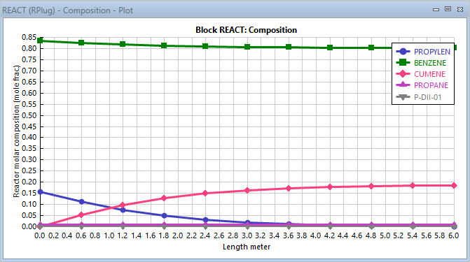
Figure 2: Concentration profiles over the kinetic reactor
NOTE – For your reactor setup you may use more screenshots to show what you inputted rather than text. See the full simulation example PDF handed out at the start of the term. Also for this reactor I had to go through 3 different sets of kinetic data to find some data that made sense and gave reasonable values. I say this to show you how difficult it is to obtain kinetic data that gives reasonable results. If you are having trouble setting up your reactor that is completely normal, make a note of your sources and perhaps keep these in an appendix for reference. Always be careful of units, especially activation energies. The bkp for this simulation is also available for you to look over if that is helpful.

Analysis [eg. design spec, sensitivity analysis, calculator block, recycle stream, optimization])
[To be added by yourself, looking at varying a parameter or trying to achieve a certain conversion for example.]

References
[1] M. Weber, M. Weber, and M. Kleine-Boymann. “Ullmann’s Encyclopedia of Industrial
Chemistry”, 2004. Wiley-VCH.
[2] A. Streitwieser, and C.H. Heathcock. “Introduction to Organic Chemistry,” 1992. MacMillan.
[3] University of York, “Phenol,” 2014. [Online]. Available:
http://www.essentialchemicalindustry.org/chemicals/phenol.html

[4] Engineers Guide, “Cumene production flow sheet and Process description,” 2009. [Online].
Available: http://enggyd.blogspot.ca/2009/09/cumene-production-flow-sheet.html

[5] University of California – Davis, “Naming and Preparing Benzenols.” [Online]. Available:
http://sasc-specialists.ucdavis.edu/jim/118C/BenzenolFrmCumeneHydroperox.pdf
[6] S. Y. Hwang and S. S. Chen, “Cumene,” in Kirk-Othmer Encyclopedia of Chemical Technology, American Cancer Society, 2010, pp. 1–10.

[7] R. Turton, R. C. Bailie, W. B. Whiting, and J. A. Shaeiwitz, Analysis, synthesis and design of chemical processes. Apendix C: Project 6. Pearson Education, 2008.

[8] W. L. Luyben, “Design and Control of the Cumene Process,” Ind. Eng. Chem. Res., vol. 49, no. 2, pp. 719–734, Jan. 2010, doi: 10.1021/ie9011535.

